On

College Automation System

# Version 1.0

August, 2024

# Group No: 11

The Team

|  |  |
| --- | --- |
| **Name** | **Registration Number** |
| Anand Shukla | 220101120007 |
| Sundram Kumari | 220101120013 |
| Mayank Kumar | 220101120015 |
| Vikash Kumar | 220101120022 |
| Akhilesh Yadav | 220101120027 |
| Sunil Yadav | 220101130003 |
| Mukesh Yadav | 220101130004 |
| Gautam Jha | 220101130006 |
| Sahwaj Husain | 220101130007 |



* 1. **Introduction**

1. **Purpose**:

The College Automation System is designed to streamline and simplify the management of college operations. It aims to automate key processes such as student admissions, course registration, attendance tracking, examination management, and fee collection. By reducing manual work, the system enhances efficiency, ensures data accuracy, and improves communication between students, faculty, and administration. Ultimately, this system will help in delivering a more organized and user-friendly experience for all stakeholders involved..

1. **Scope of Project:**

* The system will allow students, faculty, and administrators to create profiles and manage their

information within the college database

* Students will be able to register for courses, track their attendance, and access their academic

records online

* Faculty members will be able to manage course content, record attendance,

and input grades for their students

* The system will enable the administration to manage admissions, track fee payments, and

generate reports for various academic and administrative functions.

* The system will incorporate a feedback mechanism where students can rate courses and provide

feedback to faculty and the administration

* The system could be adapted for use in different educational institutions by customizing it to

meet specific cultural and regulatory requirements.

**3. Overview:**

* + The working way of the Website is easy to Which will user friendly and the everyone can use in the very comfort way
  + **Login Module**: The Login Module provides secure access to the system for all users, including students, faculty, and administrators. It ensures that users can only access the information and functionalities relevant to their roles within the college.
  + Admin module: The admin in a college automation system manages student roles, schedules, resources, student data, reports, and system configuration efficiently.
  + Faculty module: The faculty module in a college automation system manages class schedules, student attendance, assignments, grading, feedback, and communication with students, streamlining academic and administrative tasks.
  + Student module: The Students Module manages student profiles, including personal information, course enrollments, attendance records, and academic performance. It allows students to register for courses, check their attendance, view grades, and interact with faculty members.
  + Hr/Placement module: The HR/Placement role in a college automation

system manages student recruitment, job postings, employer relations,

interview schedules, placement data, and training programs to enhance

career opportunities.

**.**  Hostel/Mess module: The hostel module handles the list of student ,room

Schedule etc and the mess in a college automation system handles

student subscriptions, menu scheduling, inventor tracking, billing,and

attendance to ensure efficient food service operations

* + Examination module: The Examination module in a college automation

system handles exam scheduling, question paper generation, grading,

result processing, student performance analysis, and report card distribution.

* **References:**
  + <https://ww>w.justd[ial.com/](http://www.justdial.com/)
  + https://talentbattle.in/login
  + https://internshala.com/
  + https://accounts.ccbp.in/login?client_id=otg&call_back_url=https://learni ng.ccbp.in/&mode=otp&WINDOW_MODE=IN_APP

1. **Key features**

* **User-Friendly Interface**: The system features an intuitive and easy-to-navigate interface for

students, faculty, and administrators, ensuring smooth interaction with all modules.

* **Centralized Database Management**: All student, faculty, course, and branch data are stored in a centralized database, allowing for efficient data retrieval, updating, and management.
* **Automated Registration Process**: The Registration Module simplifies course registration by automating the enrollment process, managing prerequisites, and tracking seat availability in real-time.
* **Real-Time Attendance Tracking**: The system allows for real-time attendance tracking for both students and faculty, with instant access to attendance records and automated notifications for low attendance.
* **Comprehensive Course Management**: The Courses Module provides detailed information about each course, including syllabi, schedules, and assignments, and allows faculty to manage course content and grading.
* **Branch-Specific Customization**: The Branches Module enables the college to manage different departments independently, offering customized options and reports for each branch.
* **Secure Login and Role-Based Access Control**: The Login Module ensures secure access to the system with role-based access control, allowing users to access only the information and
* functionalities relevant to their roles.
* **Performance Tracking and Reporting**: The system provides detailed reports on student
* performance, faculty activities, and overall college operations, helping in data-driven decision-making.
* **Communication Tools**: Integrated messaging and notification systems facilitate communication between students, faculty, and administration, ensuring timely updates and information sharing.
* **Scalable and Adaptable Architecture**: The system is designed to be scalable, allowing for easy expansion as the college grows. It can also be adapted to different educational institutions with minimal customization.
  1. **Challenges:**

Developing the College Automation System presents several challenges, including integrating diverse modules into a seamless platform while ensuring data consistency across all functions. Ensuring robust security to protect sensitive student and faculty data is critical, along with managing user authentication and access control. Another challenge is designing a user-friendly interface that meets the needs of various users—students, faculty, and administrators—without overwhelming them. Additionally, scalability must be considered to accommodate future growth, and the system must be adaptable to different institutions' unique requirements. Lastly, thorough testing is

**1.3. Glossary:**

|  |  |
| --- | --- |
| TERMS | DEFINITION |
| Admin | Admin can be given the access of users. In case of multiple admin, This term refers to the main admin. With whom all communication is made. Like, He can do many things like giving access, changing services details, add recent services etc. |
| Database | Collection of the data monitored by this system. |
| Editor | The person who receives the students information and verify that and sends that main information to main admin. |
| Viewer | Anyone visit the website to read (or) saw the services. |
| Users | They are signup (or) login in our website they can get the services. Without login they can’t book our services.  (Administration,Students,Faculty ) |
| Students | The Students are the main user of the website who will use for see their information as well as the course detailed which will be assigned by the faculty |
| Faculty | Here faculty will be in the role of the admin where he will manage students details |
| Scope of Work | The websites will be used in the college to automate the Functionalities |
| Login Module | Login module are different for the different user such as for the faculty that will be used the Admin how can update the data related to the Students. |
| Examination module | Examination Module will handle the Examination Process of our website where we will able to Schedule the examination for the the different different students as well as with the Different Subjects |
| Registration module | Registration will be defined for the students while taking the admission in the collage |
| Account module | All the Work related to the money transection will be handle through the  Account section which includes the fee of the students and Sallery of the  Faculty . |
| Hostel /Mess | Hostel and the mess Includes and food as well as the Accommodations from the allotting to the room mess foods this will be includes the Hostel  And mess module. |



* 1. **Software and Hardware specifications**
     1. Software requirements
* Eclipse IDE (Editor)
* XAMPP Server
* Spring Tool Suite (STS) (Application Build tool)
* Visual Studio Code (Editor )
* Tomcat server (Server) 10.1 & More
  + 1. Language Support Software
* JDK 1.8 & More
  + 1. Client-Side tool
* Angular
  + 1. Hardware requirements
* Operating system: windows 10 & 11
* 11th Gen Intel(R) Core (TM) i5-1155G7 @ 2.50GHz 2.50 GHz
* System type: 64-bit Operating System
* RAM: 8 Gb or more
* ROM: 256 SSD Or More
  1. **Technologies used**

1. Front-End: Angular, Css, Bootstrap
2. Back-End: Spring boot(framework)
3. Webservices: REST (RESTful API)
4. Database : MYSQL
5. Server: Tomcat 10.1
6. Dependencies: Spring-web, Spring-data JPA,MYSQL Driver, Spring Security.

The College Automation System is a comprehensive software solution designed to streamline the administrative and academic operations of a college. Focusing on six key modules—Faculties, Students, Registration, Courses, Branches, and Login—this system aims to enhance efficiency, accuracy, and communication within the institution. By automating tasks such as course registration, attendance tracking, and performance reporting, the system reduces manual workload and minimizes errors. The centralized database and role-based access ensure secure management of all academic data. Despite challenges like ensuring data security and system integration, the project is expected to deliver a scalable and user-friendly platform that supports the dynamic needs of a modern educational institution.

**Abstract**



**Block diagram of our Project** These are Certain blocks Present in this Project

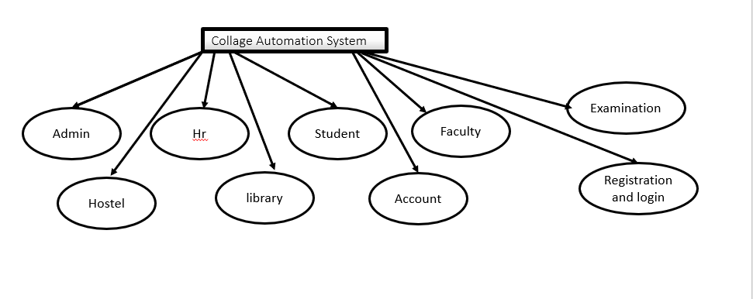



# **Modules and Functionalities**

Here we are going to explain about the Module whatever we have created inside our project which led to know about the functionality of the our project which is specially designed to automate the college functionalities decrease the load of the manual working

.

They will interact with following Modules

**4.1 Faculties Module:**

The Faculty module deals with the function of the student monitoring which is done by Faculty

Which includes the function od the Attendence, report card and all related information about the Student ,Where faculty can edit the information about them

They are listed below _

1.Attendence

2.Marks

3.Subject Allotments

**4.2** **Students Module:**

A navigation bar will contain browsing access to other modules. On the page, it should contain five sections:

1. Registration sections for Employes.
2. Advertisement for the Local organizations for Part time jobs. 3.Services based on different Categories of User Problems/issues. 4.Job Services section to provide part time jobs in local organizations. 5.About Section – it should Contain all the details of the Website.

**4.3Admin:**

Admin will be responsible to manage the details of all the Users, Employes, and Part time job organizations. Like admin can add new services, Organizations to part time jobs of local area and view the list of existing services and Employes, Admin can Approve the order from the user, Admin can check the Availability of the services in the application.

* + - Admin can ADD/DELETE/UPDATE/VIEW User and Employe details.
    - Admin can ADD/DELETE/UPDATE the Services.
    - Admin can ADD/DELETE/APPROVE the Requests from the User and Employe.
    - Admin can VIEW the number of User and Employe.
    - Admin can Access the availability of the Employe for the Services.

The Administrator can do the following actions

1. Login
2. Admin Actions
   1. Number of Users in a graphical form
   2. Number of Employes in a graphical form
   3. Number of Services in a graphical form
   4. Views/Update/Delete personal details of User and Employe
   5. Views/Update/Delete Services
3. Logout

**ADMIN**

**Use Case Diagram for Admin**

**Hostel/Mess**

**Student/Faculty**

|  |  |
| --- | --- |
| **Use Case ID:** | **Use Case Name**:Admin |
| **Description** | Admin can login into the Application with valid credentials. After entering the dashboard, update and manage services, update reports. |
| **Actor** | Admin |
| **Preconditions** | Admin, should have a valid account |
| **Post conditions** | Admin, will be logged in. |
| **Events** | The admin opens the website and it will direct to the login page.  The admin can add/update/delete Alerts.  The admin can manage Services.  Admin can update reports. |
| **Exceptions** | If admin enters wrong user ID and Password, they cannot login to the system it will show login failed. |

**ACTIVATE FLOW DIAGRAM OF ADMIN**:-

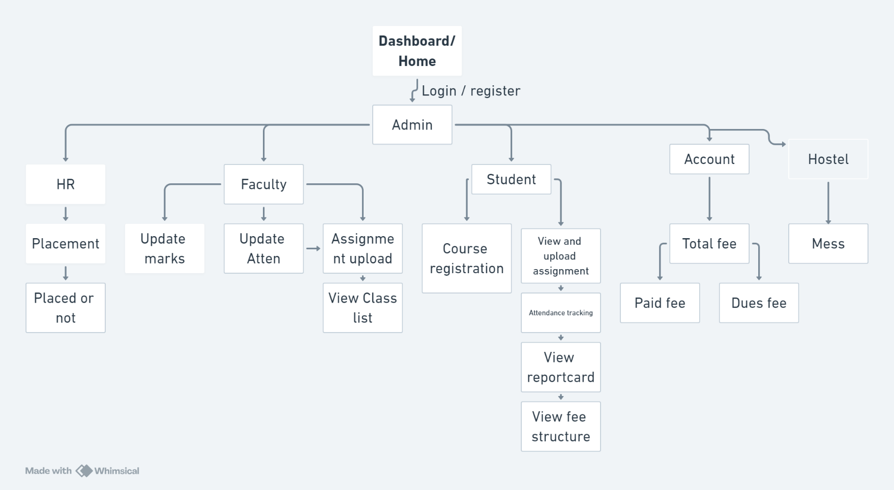

**Hr/Placement**

* Hr can manage all the problems related to placements.
* Hr can conduct placement interview.
* Keep track of all placement activities for future references and audits.
* Arrange for meetings with department heads or senior management.

**Use Case Diagram of User :-**

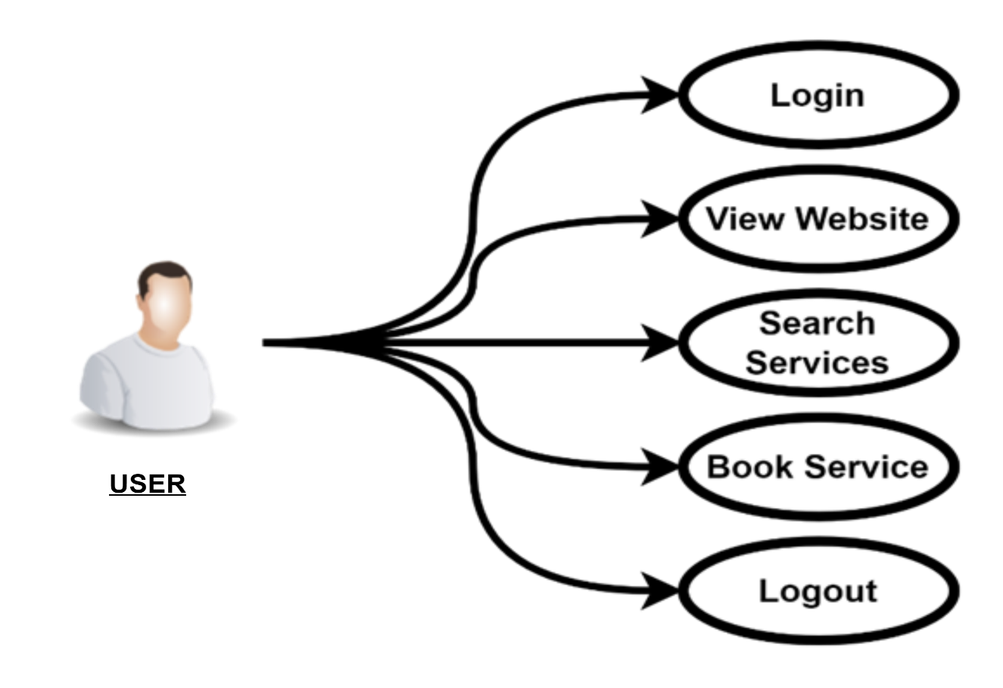

**Login**

**Login**

**Conduct Interview**

**Conduct Interview**

**Select Students**

**Send Offer Latter**

**Hr**

**Send Offer Letter**

**Logout**

**Logout**

|  |  |
| --- | --- |
| **Use Case ID:** | **Use Case Name**:Hr |
| **Description** | Hr can manage the placement team and conduct the placement interview and select the student for placed |
| **Actor** | Hr |
| **Preconditions** | Hr must have a valid account |
| **Post conditions** | Hr have to login |
| **Normal Course of Events** | The Hr opens the website and he can make a list for placed students |



**ACTIVATE FLOW DIAGRAM OF HR**:-

**Login**

**Final Placement Decision**

**Selection & Offer Letter**

**Assessment & Evaluation**

**Conduct Interviews**

**Interview Scheduling**

**Faculty**

● Faculty should be able to use the website for various academic services related to students and courses.

● Faculty need to register on the platform and get approval from the Admin to become active faculty members, enabling them to access the system's teaching resources.

● Once registered and approved by the Admin, the Faculty can manage and update student information, such as marks, attendance, and course progress.

● Faculty can also view their assigned courses and branch-related information and interact with the system as a regular user for any general tasks (such as booking resources or accessing internal services).

● Faculty can receive notifications or updates related to the academic work and also perform student evaluations and grading, which are verified and approved by the Admin before being finalized.



**Use Case Diagram of Faculty :-**

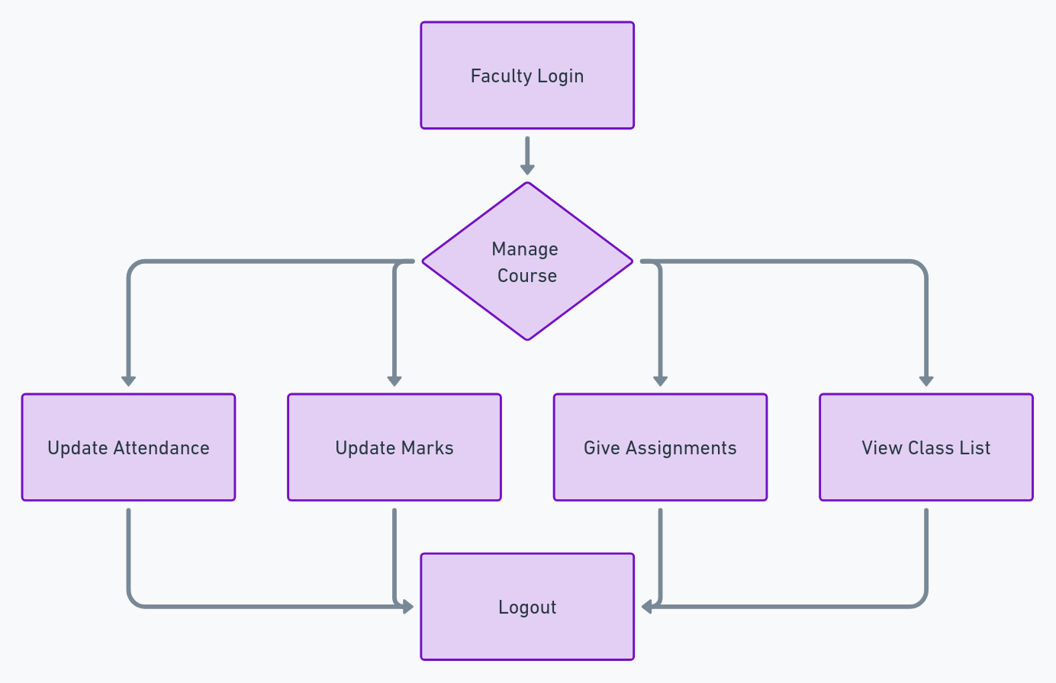

|  |  |
| --- | --- |
| **Use Case ID:** | **Use Case Name**: Faculty |
| **Description** | After login the faculty , he reaches his dashboard and view the details of the registered Students, where he will be  Able to perform his works |
| **Actor** | Faculty |
| **Preconditions** | Faculty, should have a valid account |
| **Post conditions** | Faculty will be logged in. |
| **Events** | faculty can open and view his dashboard, then he can see the students details and also able update their data |
| **Special Requirements** | Working-hours. |
|  |  |

**ACTIVITY FLOW DIAGRAM OF EMPLOYEE :-**

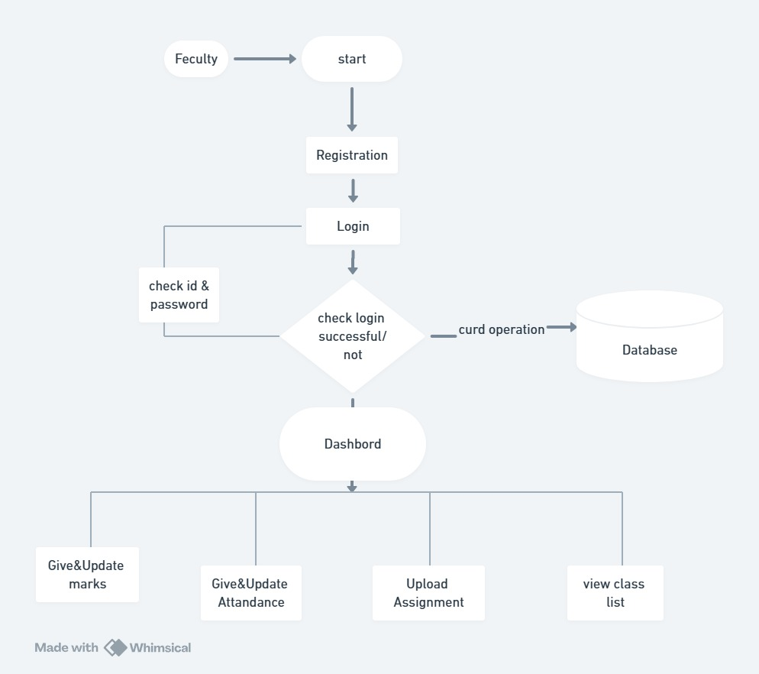

**(Students)**

* + - Student can visit the Website for Details.
    - Student can Access to view the details whatever updated by the faculty
    - Student can manage his/her course details
    - Student can make payment through website that may be from the direct to account.
    - Student can see their marks which will be updated by the faculty
    - Student can use direct contact to the faculty through the given number

**Use Case Diagram of User(student) :-**



**Login**

**View attendance**

**View Marks**

**student**

**View Course**

**Logout**

|  |  |
| --- | --- |
| **Use Case ID:** | **Use Case Name**:User |
| **Description** | Student can see their information if he want anything , then login and view, the Attendence marks, fee and the courses whatever he wants In the application. |
| **Actor** | User (students) |
| **Preconditions** | User must have a valid account |
| **Post conditions** | User have to login. |
| **Normal Course of Events** | The students opens the website and he can view the services. |



**ACTIVITY FLOW DIAGRAM OF STUDENT:-**

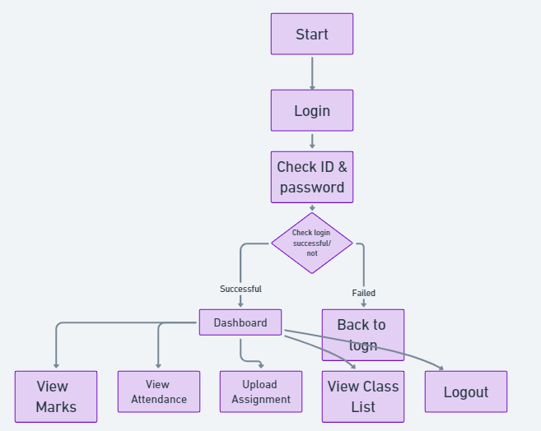

**Account**

• Admin **can manage student fee structures** for different courses and departments.

• Admin can update payment details for each student (e.g., fees paid, pending payments).

• Admin **can generate and download financial reports** regarding payments and dues.

• Admin **can track payment history** and issue receipts to students.

• Student**s can make payments** directly through the website (online banking, UPI, etc.).

• **S**tudents **can view their payment history** and check pending dues

• Admin **can notify students** about upcoming payment deadlines or issues with payments.

**Login**

**Update fee**



**Faculty Salary**

**Account Data**

**Payroll system**

|  |  |
| --- | --- |
| **Use Case ID:** | **Use Case Name**: Account |
| **Description** | Student can see their information if he want anything , then login and view, the Attendence marks, fee and the courses whatever he wants In the application. |
| **Actor** | Finance |
| **Preconditions** | Admin should have the Access |
| **Post conditions** | User have to login. |
| **Normal Course of Events** | The students opens the website and he can view the services.  Whereas the Admin will manage the  all processes and the transection |

**ACTIVITY FLOW DIAGRAM OF ACCOUNT**

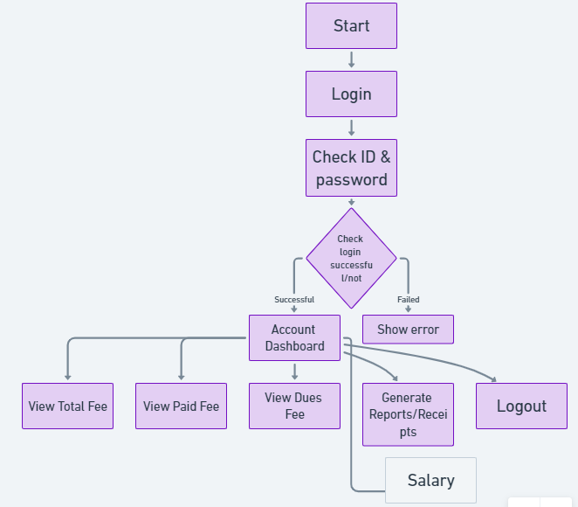

Faculty

**HOSTEL**

* Admin can manage and update all financial records, including student fees and payments.
* Students can view their fee structure, due dates, and pending payments.
* Students can make secure online payments through the website.
* The system provides automated fee receipts and transaction history for each payment made.
* Admin can generate financial reports, such as fee collection summaries and outstanding payments.
* The module supports multiple payment methods (bank transfer, credit card, etc.) for ease of use.
* Students can view any fines or penalties incurred and make payments accordingly.
* Faculty or admin can update payment statuses and track completed or pending payments.

**Manage room**

**Room Allotment**



**Update and delete student**

**Student Leave**

|  |  |
| --- | --- |
| **Use Case ID:** | **Use Case Name**: Hostel/Mess |
| **Description** | This module will deal with Food as Well as the Accommodation in the  Collage Campus Along With the all  Administration work |
| **Actor** | Admin |
| **Preconditions** | Student should belong to University |
| **Post conditions** | Student should be hosteller |
| **Normal Course of Events** | The students opens the website and he can view the services.  Whereas the Admin will manage the  all processes and the System to add them |

**ACTIVITY FLOW DIAGRAM OF STUDENT**

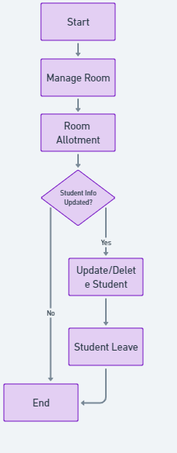

**LIBRARY**

• Admin can manage and update all library records, including book inventory, issuance, and returns.

• Students can view the list of available books, due dates, and borrowed book history.

• Students can reserve or request books online through the website.

• The system provides automated return receipts and issuance history for each book borrowed.

• Admin can generate reports, such as overdue books, borrowed book summaries, and

library usage statistics.

• The module supports multiple features like book reservations, renewals, and fine

calculations for overdue returns.

• Students can view any fines or penalties incurred for late returns and make payments

online.

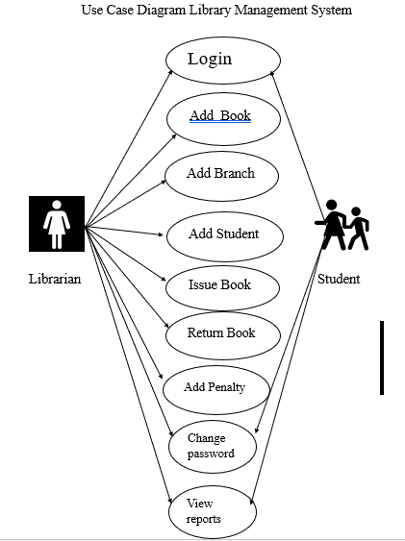

|  |  |
| --- | --- |
| Use Case ID: | Use Case Name :- Librarian |
| Description: | Librarian can be login into Application with  Valid credentials. After entering the dashboard, update and manage services, update report |
| Actor | Librarian |
| Pre conditions | Librarian, should have a valid account |
| Post condition | Librarian will be logged in. |
| Events | The Librarian opens the website and it will direct to the login page.  The Librarian can do the add book\ add branch/ add student /issue book/ return book/ add penalty  Librarian and Student can see the view Reports and change the password |

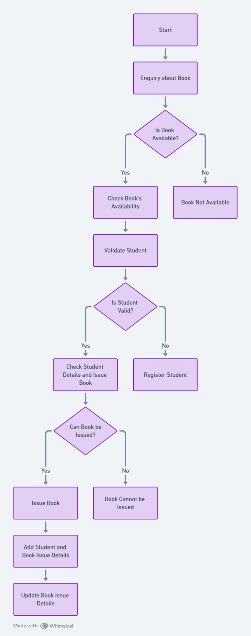

**Activity Flow Diagram**

EXAMINATION

• **Students can view their exam schedules** and seating arrangements through the website.

• **Students can access and download admit cards** for upcoming exams.

• **Faculty can upload exam results**, and students can view their grades directly on the platform.

• **Admin can manage and update examination timetables** for all courses and branches.

• **Faculty can upload and modify internal assessment marks** for students.

• **Admin can generate and distribute exam-related reports**, including student performance statistics.

• **Students can receive notifications** about upcoming exams, result releases, and deadlines for retakes.

Schedule Exam

Admit Card



Result

Sitting Arrangemrnt

|  |  |
| --- | --- |
| Use Case ID | Use Case Name: Examination |
| Description | All the examination Process Will be Handel from here  this module is about to schedule and conduct of the exam along with proving the Admit cards as well as result |
| Actor | Exam cell |
| Preconditions | Student should be the part of the any program of collage |
| Post conditions | Must have Admit card |
| Events | faculty can open and view his dashboard, then he can see the students details and exam details, exam schedule also able update their data |
|  |  |

**Activity Flow Diagram**

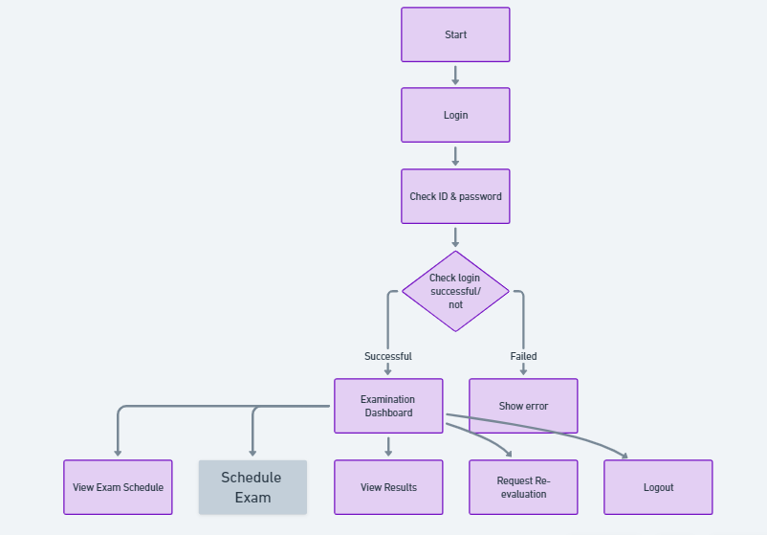



**Overview**:

This SRS document contains many use case diagrams and descriptions about all use case diagrams have been included in this document. It also gives the functional and non-functional requirements.

**-**